1.Draw a Use Case Diagram for an online Library Management System

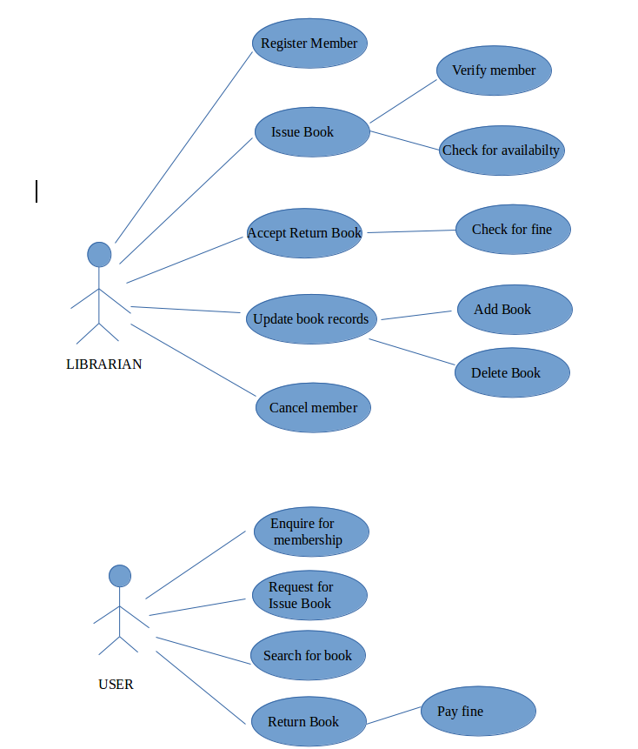

2.List down the best practices from Agile/Scrum
methodology

- Development process and practices facilitated by a dedicated role
- Sprint planning meeting to create sprint backlog
- Planning poker to estimate tasks during sprint planning
- Time-boxed sprints producing output in time
- Mutual commitment to sprint backlog between product owner and team
- Short daily meeting to resolve current issues
- Self organizing team.
- Burn down chart to monitor sprint progress
- Sprint review meeting to present completed work
- Sprint retrospective to learn from previous sprint
- Release planning to release product increments
- Give the team a dedicated open work space
- The customer is always available
- test driven development
- pair programming
- Refactor whenever and wherever possible

3.Collaboration
a.How does collaboration help agile development?
b.What if the team is distributed and can you achieve the same productivity?
c.What would you do to achieve the productivity for a distributed team?

a. Collaboration simply means to work jointly rather than independently to accomplish a task.
Agile methodology stress the benefits of working with cross-functional teams to encourage strong communication between business owners, from whom we get requirements for products, and the technical team that produces the product. Collaboration is also very important between members of the technical team. Agile methodologies promote frequent and face-to-face communication between all team members.
Two of the four values in the Agile Manifesto highlight the emphasis Agile methodologies place on strong collaboration. "Individuals and interactions over processes and tools" reminds us of the importance of strong and respectful communication.
"Customer collaboration over contract negotiation" reminds us that it's more important for a development team to allow for some flexibility to please a customer, seeking a collaborative solution to issues that might arise during product development, rather than to stick to a rigid contract.

b. If the team is distributed we can’t achieve the same productivity because it will be very difficult if a problem occurs during the project
The issues in distributed development are:
Strategic: Difficult leveraging available resources, best practices are often deemed proprietary, are time consuming and difficult to maintain.
- Project and process management:Difficulty synchronizing work between distributed sites.
- Communication:Lack of effective communication mechanisms.
- Cultural: Conflicting behaviors, processes,and technologies.
- Technical: Incompatible data formats,schemas, and standards.
c.Following are the methods to achieve productivity in a distributed agile team:
- Optimize Team Size and Team Mix:Finding the right mix of talent at every location is critical when the team is distributed.Effective distributed Agile development is about minimizing the impact of distribution.
- Distribute Work Evenly:Make sure all team members understand their role and have fairly equal workloads. In a distributed team, if the workload is uneven, you may risk the overall project delivery schedule if you ignore the imbalance. Uneven workloads can also cause bottlenecks
- Set Up Pair Programming:Pair programming, where two team members sit side by side and work on the same code, is a challenge for distributed teams
- Enforce and Re-enforce Agile Practices:Agile approaches rely on a set of mutually supporting practices. When one practice doesn’t make sense for one team, the practice should be either abandoned or replaced. With distributed teams, enforcing and reinforcing a practice takes time and effort
- Use Online Tools for Agile Artifacts:take advantage of Agile process artifacts (white boards, sticky notes, and so on) by moving them from their physical environment to an online tool.
- Understand Time Differences
- Understand Cultural Differences
- Adapt Communication for Remote Teams
- Arrange Face-to-Face Interactions
- Plan Frequent Demos and Retrospectives

4.What is Sprint Zero in Agile?
Describe the activities that are done in Sprint Zero

Sprint zero can be defined as the preparation period before real sprints start.
The Sprint goal behind a Sprint 0 is “being ready and able to deliver business value that is usable and potentially releasable”.

Activities include :-
- Involving the stakeholder

Stakeholder/customer should be included during the sprint 0

- Obtain funding and support

A planning is done for the funding and support

- Setup environment

A place is selected for the meeting where they can discuss about the future sprints

- Product Backlog/Requirement
These are the product requirements that team will be building in the coming sprints.
- Infrastructure readiness
Without the infrastructure, team will not be able to progress on anything. So a high dependency on the systems, software, licenses, environments etc. Delivery Manager need to work with the infra stakeholder to get these things done.

- Design/Architecture
High level architecture management plan that talks about the technical architecture of the future product from the technical architect. Next step will be to convert the architect plan into the architecture solution i.e. the coding platform for the developers.
- Team Readiness
Creation of the team as per the resourcing plan. You do not need the entire team on day 1 of sprint 0. But you have to make the team ready with the training, tools, systems configured for them for coming sprint
- Training
Training will make team ready for the development/testing. These trainings are critical to project success. I would also recommend that these trainings should be recorded for the future use. Recorded sessions will be utilized during the ramp up period for the new associates.

- Project Management Plan
Comprehensive project management plan will be the bible for the project team members as far as project processes are concerned. Agile PMP document is different than the traditional PMP. Here critical items are the test and defect management plan. You should clearly write down the process of testing in the project. What kind of testing?; which environment will used for which testing?; how many types of defects?; how will team fix the defects?; all these questions should be answered by the test strategy.

